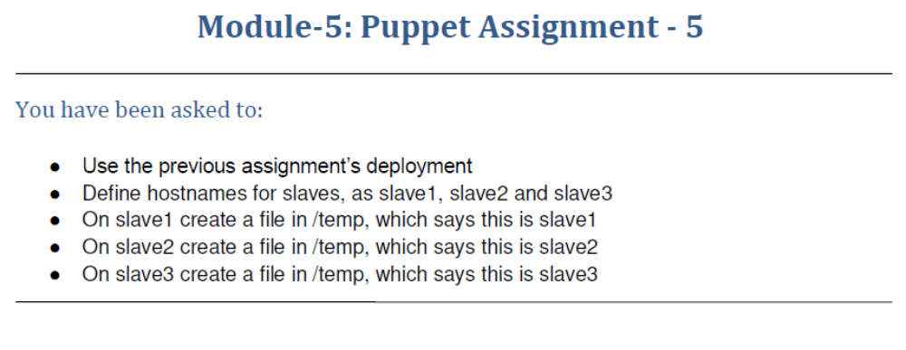
ubuntu@ip-172-31-33-191:/etc/puppet/code/environments/production$ ls
manifests modules
ubuntu@ip-172-31-33-191:/etc/puppet/code/environments/production$ cd modules/
ubuntu@ip-172-31-33-191:/etc/puppet/code/environments/production/modules$ sudo mkdir slave1
ubuntu@ip-172-31-33-191:/etc/puppet/code/environments/production/modules$ cd slave1
ubuntu@ip-172-31-33-191:/etc/puppet/code/environments/production/modules/slave1$ sudo mkdir manifests
ubuntu@ip-172-31-33-191:/etc/puppet/code/environments/production/modules/slave1$ cd manifests/
ubuntu@ip-172-31-33-191:/etc/puppet/code/environments/production/modules/slave1/manifests$ sudo nano init.pp
ubuntu@ip-172-31-33-191:/etc/puppet/code/environments/production/modules/slave1/manifests$ cd ..
ubuntu@ip-172-31-33-191:/etc/puppet/code/environments/production/modules/slave1$ cd ..
ubuntu@ip-172-31-33-191:/etc/puppet/code/environments/production/modules$ mkdir slave2
mkdir: cannot create directory ‘slave2’: Permission denied
ubuntu@ip-172-31-33-191:/etc/puppet/code/environments/production/modules$ sudo mkdir slave2
ubuntu@ip-172-31-33-191:/etc/puppet/code/environments/production/modules$ cd slave
-bash: cd: slave: No such file or directory
ubuntu@ip-172-31-33-191:/etc/puppet/code/environments/production/modules$ cd slave2
ubuntu@ip-172-31-33-191:/etc/puppet/code/environments/production/modules/slave2$ sudo mkdir manifests
ubuntu@ip-172-31-33-191:/etc/puppet/code/environments/production/modules/slave2$ cd manifests/
ubuntu@ip-172-31-33-191:/etc/puppet/code/environments/production/modules/slave2/manifests$ sudo nano init.pp
ubuntu@ip-172-31-33-191:/etc/puppet/code/environments/production/modules/slave2/manifests$ cd ..
ubuntu@ip-172-31-33-191:/etc/puppet/code/environments/production/modules/slave2$ cd ..
ubuntu@ip-172-31-33-191:/etc/puppet/code/environments/production/modules$ sudo mkdir slave3
ubuntu@ip-172-31-33-191:/etc/puppet/code/environments/production/modules$ cd slave3
ubuntu@ip-172-31-33-191:/etc/puppet/code/environments/production/modules/slave3$ sudo mkdir manifests
ubuntu@ip-172-31-33-191:/etc/puppet/code/environments/production/modules/slave3$ cd manifests/
ubuntu@ip-172-31-33-191:/etc/puppet/code/environments/production/modules/slave3/manifests$ sudo nano init.pp
ubuntu@ip-172-31-33-191:/etc/puppet/code/environments/production/modules/slave3/manifests$ cat init.pp
class slave3
{
file {'/tmp/status.txt':
content=> "This is slave3",
mode=>"0644",
}
}
ubuntu@ip-172-31-33-191:/etc/puppet/code/environments/production/modules/slave3/manifests$ cd ..
ubuntu@ip-172-31-33-191:/etc/puppet/code/environments/production/modules/slave3$ cd ..
ubuntu@ip-172-31-33-191:/etc/puppet/code/environments/production/modules$ ls
new slave1 slave2 slave3 stdlib
ubuntu@ip-172-31-33-191:/etc/puppet/code/environments/production/modules$ cd slave1
ubuntu@ip-172-31-33-191:/etc/puppet/code/environments/production/modules/slave1$ cd manifests/
ubuntu@ip-172-31-33-191:/etc/puppet/code/environments/production/modules/slave1/manifests$ cat init.pp
class slave1
{
file {'/tmp/status.txt':
content=> "This is slave1",
mode=>"0644",
}
}
ubuntu@ip-172-31-33-191:/etc/puppet/code/environments/production/modules/slave1/manifests$ cd ..
ubuntu@ip-172-31-33-191:/etc/puppet/code/environments/production/modules/slave1$ cd ..
ubuntu@ip-172-31-33-191:/etc/puppet/code/environments/production/modules$ cd slave2
ubuntu@ip-172-31-33-191:/etc/puppet/code/environments/production/modules/slave2$ cd manifests/
ubuntu@ip-172-31-33-191:/etc/puppet/code/environments/production/modules/slave2/manifests$ cat init.pp
class slave2
{
file {'/tmp/status.txt':
content=> "This is slave2",
mode=>"0644",
}
}
ubuntu@ip-172-31-33-191:/etc/puppet/code/environments/production/modules/slave2/manifests$ cd ..
ubuntu@ip-172-31-33-191:/etc/puppet/code/environments/production/modules/slave2$ cd ..
ubuntu@ip-172-31-33-191:/etc/puppet/code/environments/production/modules$ cd ..
ubuntu@ip-172-31-33-191:/etc/puppet/code/environments/production$ ls
manifests modules
ubuntu@ip-172-31-33-191:/etc/puppet/code/environments/production$ cd manifests/
ubuntu@ip-172-31-33-191:/etc/puppet/code/environments/production/manifests$ sudo nano site.pp
ubuntu@ip-172-31-33-191:/etc/puppet/code/environments/production/manifests$

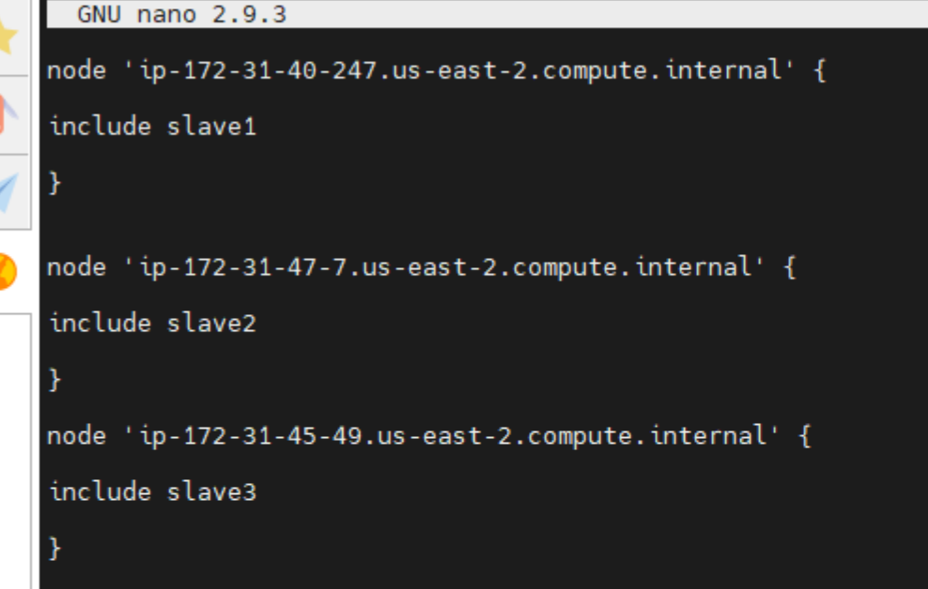
On Slave-1
ubuntu@ip-172-31-40-247:/etc$ sudo puppet agent --test
Info: Using configured environment 'production'
Info: Retrieving pluginfacts
Info: Retrieving plugin
Info: Retrieving locales
Info: Loading facts
Info: Caching catalog for ip-172-31-40-247.us-east-2.compute.internal
Info: Applying configuration version '1638960719'
Notice: /Stage[main]/Slave1/File[/tmp/status.txt]/ensure: defined content as '{md5}4e31eb7f9b3aa3b1371ff139d2524ec0'
Notice: Applied catalog in 0.02 seconds
ubuntu@ip-172-31-40-247:/etc$ cd ..
ubuntu@ip-172-31-40-247:/$ cd tmp
ubuntu@ip-172-31-40-247:/tmp$ ls
status.txt systemd-private-27af19479a484e39abfb790163c245a3-systemd-timesyncd.service-FFpAoE
systemd-private-27af19479a484e39abfb790163c245a3-systemd-resolved.service-N7TCZN
ubuntu@ip-172-31-40-247:/tmp$ cat status.txt
This is slave1ubuntu@ip-172-31-40-247:/tmp$
On Slave-2
ubuntu@ip-172-31-47-7:/etc$ sudo puppet agent --test
Info: Using configured environment 'production'
Info: Retrieving pluginfacts
Info: Retrieving plugin
Info: Retrieving locales
Info: Loading facts
Info: Caching catalog for ip-172-31-47-7.us-east-2.compute.internal
Info: Applying configuration version '1638960727'
Notice: /Stage[main]/Slave2/File[/tmp/status.txt]/ensure: defined content as '{md5}ac69687919b6285abcb53ae9003365f7'
Notice: Applied catalog in 0.02 seconds
ubuntu@ip-172-31-47-7:/etc$ cd ...
-bash: cd: ...: No such file or directory
ubuntu@ip-172-31-47-7:/etc$ cd ..
ubuntu@ip-172-31-47-7:/$ cd /tmp
ubuntu@ip-172-31-47-7:/tmp$ ls
status.txt
systemd-private-31f5bdc7a48d4e5393406e50ad52ab24-systemd-resolved.service-UQqDuW
systemd-private-31f5bdc7a48d4e5393406e50ad52ab24-systemd-timesyncd.service-s8S4RE
ubuntu@ip-172-31-47-7:/tmp$ cat status.txt
This is slave2ubuntu@ip-172-31-47-7:/tmp$
On slave-3
ubuntu@ip-172-31-45-49:/etc$ sudo puppet agent --test
Info: Using configured environment 'production'
Info: Retrieving pluginfacts
Info: Retrieving plugin
Info: Retrieving locales
Info: Loading facts
Info: Caching catalog for ip-172-31-45-49.us-east-2.compute.internal
Info: Applying configuration version '1638960736'
Notice: /Stage[main]/Slave3/File[/tmp/status.txt]/ensure: defined content as '{md5}58ca13a2d3492d196f3cbb2b07cd1662'
Notice: Applied catalog in 0.02 seconds
ubuntu@ip-172-31-45-49:/etc$ cd ..
ubuntu@ip-172-31-45-49:/$ cd /tmp
ubuntu@ip-172-31-45-49:/tmp$ ls
status.txt
systemd-private-dd9b607ceac540179ebe130dad6ea20e-systemd-resolved.service-HhZED2
systemd-private-dd9b607ceac540179ebe130dad6ea20e-systemd-timesyncd.service-JMZmYF
ubuntu@ip-172-31-45-49:/tmp$ cat status.txt
This is slave3ubuntu@ip-172-31-45-49:/tmp$

